Understanding
use case:
Autonomous AI Trust Fabric for Clinical Decision Intelligence:
Develop a platform that not only tracks data lineage but creates a Digital Compliance Twin for every AI prediction generated by a diagnostic model.

1. Problem Statement
Hospitals already use diagnostic AI models (vendor-built, black-box) to support clinical decisions — e.g., a model that reviews a chest X-ray and predicts "Pneumonia, 94% confidence." Today, that prediction is just a number and a label. There is no structured, retrievable record of:
- What exact patient data/scan produced this prediction
- Which model version made the call, and whether it was approved
- Why the prediction is clinically reasonable
- Whether the model is behaving normally over time
If a prediction is later questioned (by a doctor, an audit, or a regulator), the answer today is: dig through scattered logs and hope they still exist.
What we're building: a system that sits after the diagnostic model and automatically builds a Digital Compliance Twin for every prediction — a permanent record combining data lineage, a plain-English explanation, and a compliance check — so any prediction can be justified at any time.
We do not build, train, or modify the diagnostic model. It is treated as an external black box.

2. Users
Role | Relationship to system
Doctors / clinicians | Passive beneficiaries — see prediction + explanation in their existing workflow
Compliance, Governance & Audit stakeholders(compliance officers, hospital AI governance/IT, regulators) | Active users and indirect drivers — compliance officers and IT review flagged records, configure the rulebook, and monitor drift alerts; regulators don't touch the system directly but are the underlying reason the audit trail must exist

3. Business Value
- Reduces liability risk — every prediction has a defensible record
- Speeds up audits — minutes instead of days of log archaeology
- Regulatory readiness — ahead of tightening AI-in-healthcare rules (FDA SaMD, EU AI Act)
- Consistent trust layer across multiple third-party diagnostic tools
- Increases clinician trust/adoption via plain-English rationale

4. End-to-End Flow
[1] Pretrained diagnostic model (external / black box)
produces: prediction + confidence + model version
|
v
[2] Ingestion layer (FastAPI + Pydantic validation)
validates schema, rejects malformed input
|
v
[3] LangGraph orchestrator - runs 4 agents in sequence, shared state
|
+- 3a. Lineage Agent
| records: which patient data + which model/version produced this
|
+- 3b. Compliance Agent
| checks: approved model version? confidence >= threshold?
| sets a 'flagged' field in state if a rule fails
|
+- 3c. Explainability Agent
| LLM (GPT-4o) generates a plain-English clinical rationale
| based on prediction + patient context (not a mathematical
| explanation, since the model is a black box)
|
\- 3d. Digital Twin Assembler Agent
merges lineage + compliance result + explanation into
one final record
|
v
[4] Digital Twin Store (PostgreSQL + audit log)
every prediction, flagged or not, is stored here
|
v
[5] Trust Monitoring Agent (scheduled job, runs periodically)
scans stored twins for drift: confidence trending down,
rising flag rate for a model version, etc.
|
v
[6] Human Review Queue
only records flagged by Compliance or Trust Monitoring land here
doctor / compliance officer confirms or overrides
|
v
[7] Clinical Dashboard
prediction + explanation + compliance status shown together

5. Input Specification

5a. Diagnostic model input (image, external to our system)
A chest X-ray image (e.g., from the public Kaggle "Chest X-Ray Images (Pneumonia)" dataset) fed into a pretrained Hugging Face model (vit-xray-pneumonia-classification or similar). This step is outside our system boundary — included here only for completeness.

5b. Prediction record (primary input to OUR system)
{
"patient_id": "P047",
"model_name": "vit-xray-pneumonia-classification",
"model_version": "v2.1",
"prediction": "PNEUMONIA",
"confidence": 0.94,
"timestamp": "2026-07-31T10:15:00Z"
}

5c. Patient context (supporting input, per case)
{
"patient_id": "P047",
"age": 67,
"symptoms": ["fever", "cough", "shortness of breath"],
"scan_type": "chest_xray",
"relevant_history": "smoker, prior respiratory issues"
}

5d. Compliance rulebook (static reference input)
{
"approved_model_versions": ["v2.0", "v2.1"],
"minimum_confidence_threshold": 0.75,
"high_risk_conditions_requiring_review": ["Pneumonia", "Tumor", "Cancer"]
}

6. Sample Output — Explainability Agent
{
"patient_id": "P047",
"explanation": "The model's high-confidence pneumonia prediction (94%) is
consistent with the patient's presenting symptoms - fever, cough, and
shortness of breath. The patient's smoking history and prior respiratory
issues further support clinical plausibility. This explanation is based
on reported symptoms and history, not direct analysis of the scan, since
the underlying model is not interpretable at the pixel level.",
"explanation_type": "narrative_llm_generated",
"generated_at": "2026-07-31T10:16:03Z"
}

7. Sample Output — Final Digital Compliance Twin
{
"patient_id": "P047",
"prediction": { "label": "PNEUMONIA", "confidence": 0.94, "model_version": "v2.1" },
"lineage": { "source": "vit-xray-pneumonia-classification",
"input_captured_at": "2026-07-31T10:15:00Z" },
"compliance": { "model_version_approved": true, "confidence_ok": true, "flagged": false },
"explanation": "...(as above)...",
"twin_created_at": "2026-07-31T10:16:05Z"
}

8. Tech Stack
Layer | Tool | Notes
Language | Python 3.11
API | FastAPI | async, input validation via Pydantic
Orchestration | LangGraph | sequential 4-agent graph, no branching except the final flag check
LLM wrapper | LangChain | prompt templates, output parsing
LLM | GPT-4o (or Azure OpenAI) | Explainability + Compliance reasoning
Diagnostic model | Pretrained Hugging Face model | real inference, no training required
Storage | PostgreSQL | twin records + audit log
Scheduling | APScheduler (in-process) | Trust Monitoring job — Airflow not justified at this scale
Observability | LangSmith | agent-level tracing
Frontend | React / Next.js | dashboard + review queue, reuses existing Keycloak/RBAC pattern
Containerization | Docker + docker-compose | optional but recommended for reproducibility

9. Where DataOps Fits
Not a separate layer — embedded directly in the pipeline:
- Input validation (Pydantic schema) = data quality gate
- Lineage Agent = data lineage tracking
- Trust Monitoring Agent = pipeline/model observability (maps to Freshness/Distribution/Drift pillars from prior observability work)

10. Explicit Scope for This Phase (Simulated vs Real)
Component | Status this phase
Diagnostic model prediction | Real (pretrained Hugging Face model, real X-ray input)
Patient context data | Simulated
Compliance rulebook | Static, hand-authored
Explainability | Real (GPT-4o call)
Message queue | Not implemented — direct call/background task instead
Scheduler | In-process (APScheduler), not Airflow
Cloud hosting | Local only
FHIR / real EHR integration | Not implemented

11. Future Enhancements (Phase 2+)
- Real model-serving integration (pretrained model calls)
- Multi-model support (per-model rulebooks and drift baselines)
- RBAC via Keycloak
- Tamper-evident/append-only audit storage
- Real-time alerting (Slack/Teams) instead of dashboard-only flags
- Model version registry

RBAC details

RBAC Table — based on the 5 screens:

Screen | Clinician | Compliance/Governance | Notes
Login | ✅ | ✅ | Same form for both; role resolved server-side from credentials
Dashboard | ✅ View, filter, search (no review actions) | ✅ Full — view, filter, review | Sidebar nav differs per role
Twin Detail — view | ✅ Read-only, action panel absent | ✅ Read-only unless flagged | Same page, panel conditionally rendered
Twin Detail — Approve/Override | ❌ | ✅ Only when status = flagged | Override requires notes field
Rulebook Settings | ❌ Not in nav, route blocked | ✅ Full edit + change log | Route guard, not just hidden link
Trust Monitoring | ❌ Not in nav, route blocked | ✅ View + manual trigger | Route guard, not just hidden link
Audit trail (all screens) | Logged as viewer | Logged as viewer + reviewer | Every GET on Twin Detail writes a view-log entry
Two roles only, exactly as the UI spec defines — no further split needed for this POC.

How to implement it
1. Backend — the source of truth
- On login, verify credentials → look up user → issue a JWT with a role claim (clinician or compliance_governance).
- Every protected API endpoint checks that claim server-side before executing — not just "does a valid token exist," but "does this role permit this action." E.g. POST /twins/:id/review rejects with 403 if role ≠ compliance_governance.
- This is the actual enforcement layer. The frontend is UX only — never trust it alone.
2. Frontend — route guards, not just hidden links
Wrap protected routes in a guard component:
<RequireRole role="compliance_governance"> <RulebookSettings /></RequireRole>
- If the role doesn't match, render a 403 page — don't just omit the nav link and let the route still resolve if someone types the URL.
- Decode the JWT once on login, store role in app state/context, and read from that everywhere (nav rendering, conditional panels, route guards) — one source, not scattered checks.
3. Frontend — conditional rendering within a shared page
- Twin Detail is one component for both roles; the Approve/Override panel renders only if (role === 'compliance_governance' && twin.status === 'flagged'). Don't build two separate pages — keeps the read-only layout identical for both, which matches the spec.
4. Audit logging
- Log on the backend, not the frontend (so it can't be bypassed): a middleware or decorator on the Twin Detail GET route writes {user, twin_id, action: 'viewed', timestamp}; the review POST route writes {user, twin_id, action: 'approved'|'overridden', notes, timestamp}.
5. Token handling
- Store the JWT in an httpOnly cookie, not localStorage — avoids exposing it to XSS, and it's a detail worth having right for a compliance product specifically.
That's the whole implementation surface — one role claim, one guard pattern reused on the frontend, and real enforcement on the backend for every write action.

Without any jwt token just for POC now. using just routing:

RBAC without JWT

GenAI need
Good critical question — and the honest answer is: only one of the six components truly needs GenAI. The rest can (and arguably should) be plain deterministic code. Let's go through it agent by agent.
Agent | Needs GenAI? | Why / why not
Lineage | ❌ No | Pure data capture — record patient ID, model version, timestamp. Just structured logging.
Compliance | ❌ No (mostly) | Rule checks like "is this model version approved?" or "confidence ≥ threshold?" are deterministic if-else logic. GenAI here would actually be worse — non-deterministic outputs are a liability in a compliance-critical, auditable pathway.
Explainability | ✅ Yes — this is the real use case | The model is a black box with no SHAP/feature-importance access. An LLM is genuinely the only practical way to produce a human-readable clinical rationale from the prediction + patient data.
Twin Assembler | ❌ No | Just merges JSON records into one document.
Trust Monitoring | ⚠️ Partially | Drift detection (declining confidence trend, anomalous distribution) is a solved problem with statistics — moving averages, z-scores, control charts. That should be deterministic. GenAI could add value by summarizing the trend in plain language for a report ("confidence has dropped 12% over 9 days, correlating with weekend shifts") — but that's a nice-to-have, not core detection.
Human Reviewer | ❌ No | Human, not AI.
So is it worth it? Yes — but the framing "AI Trust Fabric" is a bit misleading if you read it as "AI everywhere." What's actually valuable is:
- One genuinely hard problem GenAI solves well: turning an opaque prediction into a readable clinical narrative when you have zero model internals to work with.
- Orchestration value, not intelligence value: LangGraph/multi-agent framing here is mostly about pipeline structure (sequential steps, conditional branching to human review, scheduled batch jobs) — not about needing "AI" at every node. You could build 5 of 6 nodes with a Python script.
Worth flagging as a real risk for your senior/team The Explainability Agent's LLM-generated rationale is a plausible-sounding story, not a true derivation from the model's actual decision process. It's built from the same patient data + prediction the LLM sees — so it could sound convincing while being wrong (hallucinated correlation, not causation). In a clinical/audit context, that's worth explicitly labeling as "AI-generated plausible rationale, not verified model interpretability" — otherwise it risks being mistaken for real explainability (like SHAP), which could be a compliance/liability problem itself.
Bottom line: GenAI is necessary for 1 node, optional-nice-to-have for another, and unnecessary (or actively risky) for the remaining 4. The project's real value is the architecture and audit discipline, with GenAI as a targeted tool for the one truly black-box problem — not the headline feature.

Diagrams
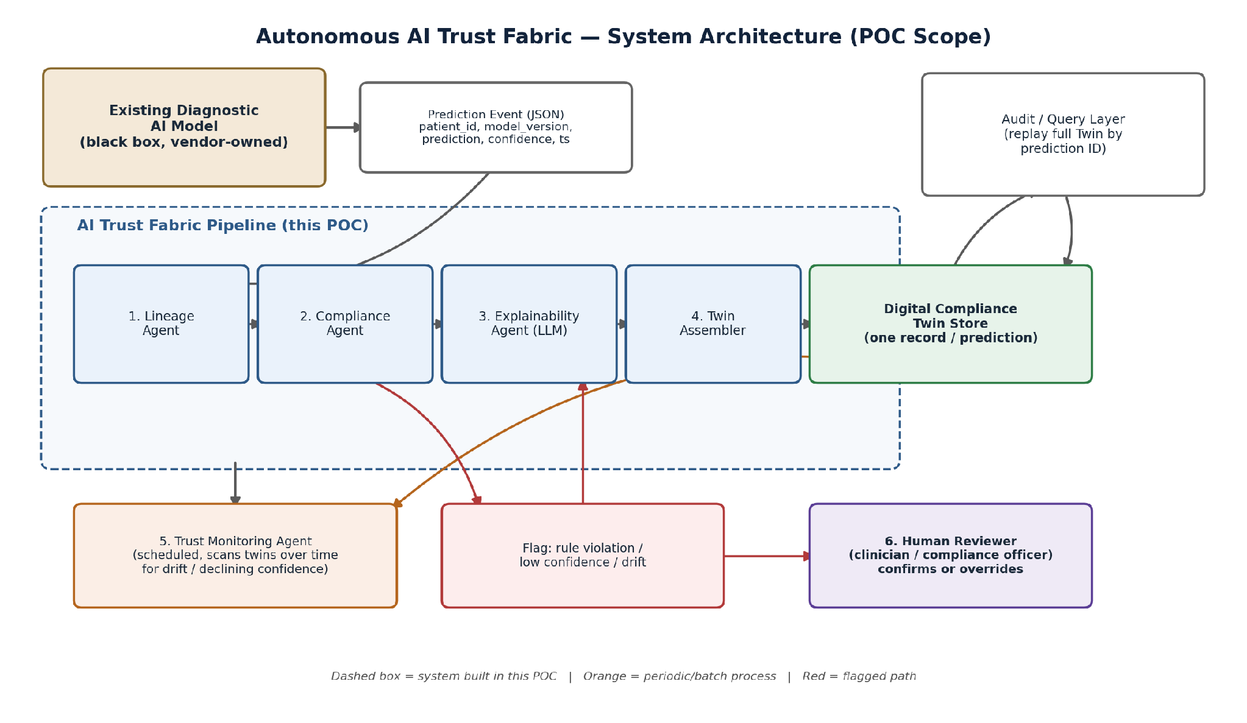
Figure 1. High-level architecture — Trust Fabric pipeline sits downstream of the black-box diagnostic model.

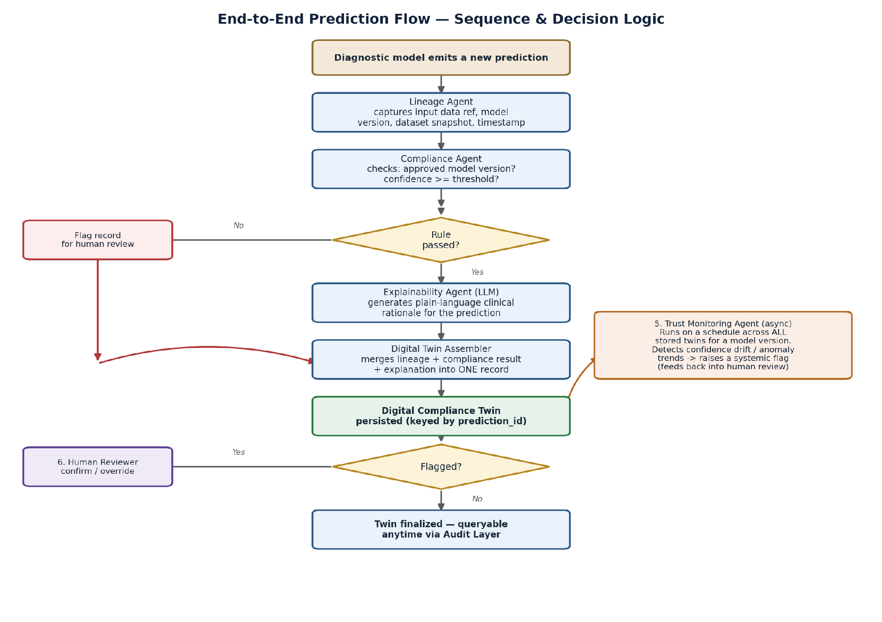
Figure 2. Sequence and decision logic for a single prediction, plus the async Trust Monitoring path.

